Lab - Troubleshoot IPv4 and IPv6 Addressing Issues

Topology
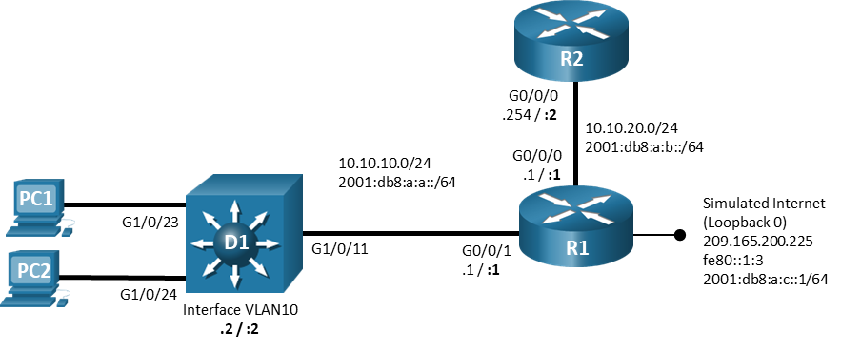

Addressing Table
Device | Interface | IPv4 Address/Mask | IPv6 Address/Prefix | IPv6 Link Local
R1 | G0/0/0 | 10.10.20.1/24 | 2001:db8:a:b::1/64 | fe80::1:1
R1 | G0/0/1 | 10.10.10.1/24 | 2001:db8:a:a::1/64 | fe80::1:2
R1 | Lo0 | 209.165.200.225/29 | 2001:db8:a:c::1/64 | fe80::1:3
R2 | G0/0/0 | 10.10.20.254/24 | 2001:db8:a:b::1/64 | fe80::2:1
D1 | VLAN 10 | 10.10.10.2/24 | 2001:db8:a:a::2/64 | fe80::d1:1
PC1 | NIC | DHCP | SLAAC | EUI-64
PC2 | NIC | DHCP | SLAAC | EUI-64

Objectives
Troubleshoot network issues related to IPv4 Addressing - DHCP.

Background / Scenario

In this topology, router R1 provides connectivity to a simulated internet for VLAN 10. R2 serves as a DHCP server. Switch D1 provides connectivity for VLAN 10. Configurations have already been loaded to the devices with errors. Your tasks are to FIND the error(s), document your findings and the command(s) or method(s) used to fix them. FIX the issue(s) presented here and then test the network to ensure both of the following conditions are met:
        - the complaint received in the ticket is resolved
        - full reachability is restored
        - You have documented your troubleshooting process on Moodle and given your unique code once the file has been completed to 100%.
        - You must log into each activity file using your name and student number. You cannot log in using a Guest account. Sample shown below. If you share your file with another student, the file will reset if the profile is changed. There will also be a new code if the activity is resets.
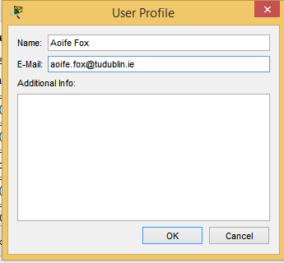

Instructions

Trouble Ticket 1 - DHCP
Scenario:
PC1 is unable to access resources on web server 209.165.200.225.
- PC1 and PC2 should be configured for and receive an address from an IPv4 DHCP server.
- Passwords on all devices are cisco12345. If a username is required, use admin.

Sample Troubleshooting Process for this Ticket

- The administrator begins the troubleshooting process by verifying IP connectivity to both workstations using c:\>ipconfig. You notice that neither workstation has obtained an IP address from the DHCP server.
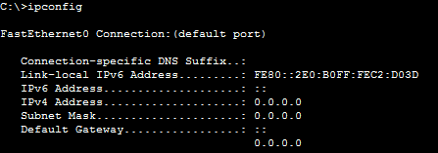

- You change the IP settings on each workstation to automatic and verify their addresses once more. Both IPv4 and IPv6 is set to automatic. See completion score.

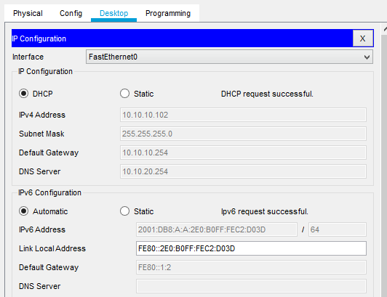

- The administrator continues to troubleshoot by issuing a ping from PC1 to 209.165.200.225 (web server).

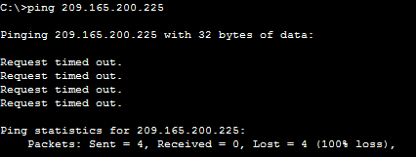

- Next, you ping the default gateway for PC1, which is R1, at 10.1.1.1. This connection is successful as shown.

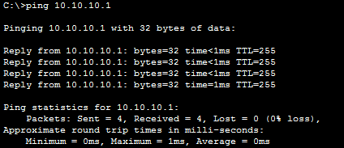

- You decide to see whether this is an isolated incident. You access PC2 and ping 10.10.10.1, which is successful, as shown. A ping to the web server from PC2 is also failing.

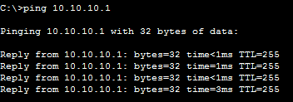

- At this point, you have determined that Layer 2 and Layer 3 connectivity from PC1 and PC2 to the router is fine. You have also confirmed that PC2 cannot reach Internet resources as well as PC1. There are many reasons this situation might exist. One of the big ones is that an access control list (ACL) on Gig0/0 or Gig1/0 is denying PC1 from accessing resources on the Internet. Alternatively, a NAT issue could be preventing 10.1.1.10 from being translated. However, before you go down that path, review the basics. For example, what about the default gateway configured on PC1? If it is configured incorrectly, PC1 is sending packets that are destined to a remote subnet to the wrong default gateway. If you review the output of ipconfig on PC1, you see that the default gateway is configured as 10.10.10.254, which is not the IP address of R1’s interface.

- The administrator moves to R2 to verify DHCP settings on the server. On inspection, the default-router IP is incorrect. You reconfigure this mistake and verify connectivity.

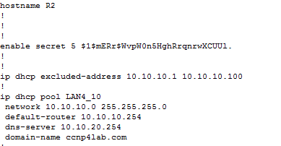

- The following commands were changed on R2, the DHCP server.

R2(config)#ip dhcp pool LAN4_10
R2(dhcp-config)#no default-router 10.10.10.254
R2(dhcp-config)#default-router 10.10.10.1

- You verify the changes made using ipconfig /release and /renew and ping to the web server.

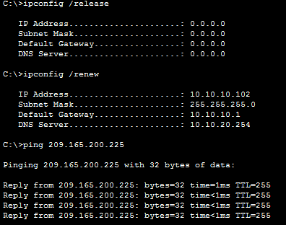

Note:
A completion code will be displayed under check results. Please enter this code into Moodle.
Codes are unique. This means every time the activity is reset, the code will change.
No two codes are the same. Please do not share your code with another student. Students will get 0 for labs, in this scenario. Codes are checked every week.

